**\*\*\*\*\*\*\*\*\*\*\*010-customFont.css\*\*\*\*\*\*\*\*\*\*\*\*\*\*\*\*\*\*\*\*\*\*\*\*\*\*\*\*\*\*\***

@CHARSET "ISO-8859-1";

h1 {

color: grey;

font-family: calibri;

}

p {

color: blueViolet;

font-family: VeggieburgerRegular

}

@font-face {

font-family: 'VeggieburgerRegular';

src: url('010-VeggiMed-webfont.ttf');

font-weight: normal;

font-style: normal;

}

****************010-demoFontText.html**************************8

<!DOCTYPE html>

<html>

<head>

<meta http-equiv="Content-Type" content="text/html; charset=ISO-8859-1">

<title>Demo on CustomFont usage</title>

<link href="010-customFont.css" rel="stylesheet">

</head>

<body>

<h1>IGATE Corporate University</h1>

<p>IGATE Corporate University in IGATE is known for providing

excellent training on JEE ,.Net, Mainframe and many more technologies.

Every new joinee in IGATE has to get trained from IGATE Corporate

University.</p>

</body>

</html>

//////////////////////////////Output is///////////////////////////////////////////



**\*\*\*\*\*\*\*\*\*\*\*\*\*\*\*\*\*\*\*011-font.css\*\*\*\*\*\*\*\*\*\*\*\*\*\*\*\*\*\*\*\***

@CHARSET "ISO-8859-1";

h1 {

color: grey;

font-family: calibri;

}

p {

color: blueViolet;

font-family: calibri;

font-size: 15px;

}

**\*\*\*\*\*\*\*\*\*\*\*\*\*\*\*011-word-wrap.html\*\*\*\*\*\*\*\*\*\*\*\*\*\*\*\*\*\*\*\*\*\*\*\*\*\*\***

<!DOCTYPE html>

<html>

<head>

<!--<link href="011-word_wrap.css" rel="stylesheet" />-->

<!--<link href="011-textShadow.css" rel="stylesheet" />-->

<link href="011-font.css" rel="stylesheet" />

</head>

<body>

<p class="p1">"Ahhhhhhhhhhhhhhhhhhhhhhhhhhhhhhhhhhhhhhhhhhhh.

Ooooooooooooooooooooooooooooooooooh. Ahhhhhhh. Ohjustonemorepiece!

Ahhhhhhhhh such rapture. Amen!"</p>

<p class="p2">"Ahhhhhhhhhhhhhhhhhhhhhhhhhhhhhhhhhhhhhhhhhhhh.

Ooooooooooooooooooooooooooooooooooh. Ahhhhhhh. Ohjustonemorepiece!

Ahhhhhhhhh such rapture. Amen!"</p>

<p class="p3">"Ahhhhhhhhhhhhhhhhhhhhhhhhhhhhhhhhhhhhhhhhhhhh.

Ooooooooooooooooooooooooooooooooooh. Ahhhhhhh. Ohjustonemorepiece!

Ahhhhhhhhh such rapture. Amen!"</p>

</body>

</html>

**///////////////////////////////Output////////////////////////////////////////**

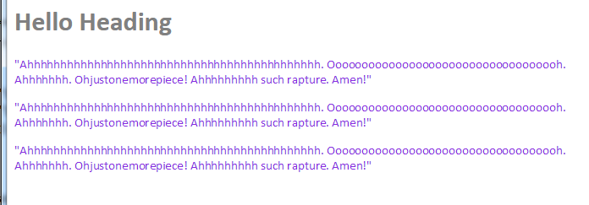

**\*\*\*\*\*\*\*\*\*\*\*\*\*\*\*\*\*\*011-word_wrap.css\*\*\*\*\*\*\*\*\*\*\*\*\*\*\*\*\*\*\*\*\*\*\*\*\*\***

.p1 {

color: red;

width: 20em;

border: 2px solid #000000;/*word-wrap:

normal|break-word|initial|inherit; And default is norma*/

}

.p2 {

color: blue;

width: 16em;

border: 1px solid #000000;

word-wrap: break-word;

}

.p3 {

color: green;

width: 11em;

border: 1px solid #000000;

word-wrap: normal;

}

**\*\*\*\*\*\*\*\*\*\*\*\*\*\*\*011-word-wrap.html\*\*\*\*\*\*\*\*\*\*\*\*\*\*\*\*\*\*\*\*\*\*\*\*\*\*\***

<!DOCTYPE html>

<html>

<head>

<!--<link href="011-word_wrap.css" rel="stylesheet" />-->

<link href="011-font.css" rel="stylesheet" />

</head>

<body>

<p class="p1">"Ahhhhhhhhhhhhhhhhhhhhhhhhhhhhhhhhhhhhhhhhhhhh.

Ooooooooooooooooooooooooooooooooooh. Ahhhhhhh. Ohjustonemorepiece!

Ahhhhhhhhh such rapture. Amen!"</p>

<p class="p2">"Ahhhhhhhhhhhhhhhhhhhhhhhhhhhhhhhhhhhhhhhhhhhh.

Ooooooooooooooooooooooooooooooooooh. Ahhhhhhh. Ohjustonemorepiece!

Ahhhhhhhhh such rapture. Amen!"</p>

<p class="p3">"Ahhhhhhhhhhhhhhhhhhhhhhhhhhhhhhhhhhhhhhhhhhhh.

Ooooooooooooooooooooooooooooooooooh. Ahhhhhhh. Ohjustonemorepiece!

Ahhhhhhhhh such rapture. Amen!"</p>

</body>

</html>

**////////////////////////////Output//////////////////////////////////////////////////////**

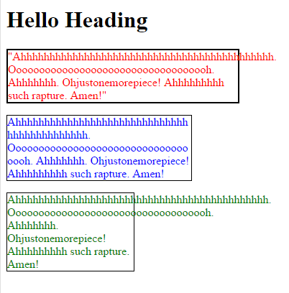

**\*\*\*\*\*\*\*\*\*\*\*\*\*\*\*\*\*\*011-text-shadow.css\*\*\*\*\*\*\*\*\*\*\*\*\*\*\*\*\*\*\*\*\*\*\*\*\***

@CHARSET "ISO-8859-1";

h1 {

color: grey;

font-family: calibri;

text-shadow: -2px 2px #003366; /*-2x is

}

p {

color: blueViolet;

font-family: myfont;

font-size: 15px;

text-shadow: 1px 1px #663366;

}

**\*\*\*\*\*\*\*\*\*\*\*\*\*\*\*011-word-wrap.html\*\*\*\*\*\*\*\*\*\*\*\*\*\*\*\*\*\*\*\*\*\*\*\*\*\*\***

<!DOCTYPE html>

<html>

<head>

<link href="011-textShadow.css" rel="stylesheet" />

<link href="011-font.css" rel="stylesheet" />

</head>

<body>

<p class="p1">"Ahhhhhhhhhhhhhhhhhhhhhhhhhhhhhhhhhhhhhhhhhhhh.

Ooooooooooooooooooooooooooooooooooh. Ahhhhhhh. Ohjustonemorepiece!

Ahhhhhhhhh such rapture. Amen!"</p>

<p class="p2">"Ahhhhhhhhhhhhhhhhhhhhhhhhhhhhhhhhhhhhhhhhhhhh.

Ooooooooooooooooooooooooooooooooooh. Ahhhhhhh. Ohjustonemorepiece!

Ahhhhhhhhh such rapture. Amen!"</p>

</body>

</html>

/////////////////////////Output////////////////////////////////

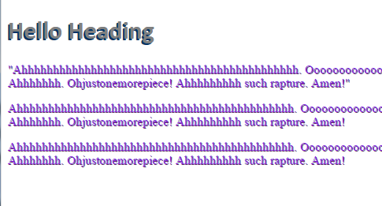

**\*\*\*\*\*\*\*\*\*\*\*\*\*\*\*\*\*021-class.css\*\*\*\*\*\*\*\*\*\*\*\*\*\*\*\*\*\*\*\*\*\*\*\*\*\*\*\*\*\*\*\***

@CHARSET "ISO-8859-1";

h1 {

font-family: calibri;

font-size: 30px;

color: blue;

text-decoration: underline;

}

.divCls {

font-family: verdana;

font-style: bold;

color: grey;

font-size: 15px;

}

.divPra {

font-family: verdana;

font-style: italic;

color: red;

font-size: 15px;

}

**\*\*\*\*\*\*\*\*\*\*\*\*\*\*\*\*\*\*\*\*\*\*021-democlass.html\*\*\*\*\*\*\*\*\*\*\*\*\*\*\*\*\*\*\*\*\*\*\*\*\*\*\*\*\*\*\***

<!DOCTYPE html>

<html>

<head>

<meta http-equiv="Content-Type" content="text/html; charset=ISO-8859-1">

<link href="021-class.css" rel="stylesheet">

<title>Class Selector Demo</title>

</head>

<body>

<h1>Learn CSS 3.0 for better web design</h1>

<div class="divCls">

<div id="d1">Do not go where the path may lead, go instead where

there is no path and leave a trail.</div>

<div id="d2">It is always the simple that produces the

marvelous.</div>

<div id="d3">As knowledge increases, wonder deepens.</div>

</div>

<div class="divPra">

<p id="p1">For beautiful eyes, look for the good in others; for

beautiful lips, speak only words of kindness; and for poise, walk

with the knowledge that you are never alone.</p>

<p id="p2">The best and most beautiful things in the world cannot

be seen or even touched - they must be felt with the heart.</p>

<p id="p3">It is during our darkest moments that we must focus to

see the light.</p>

<p id="p4">Happiness is not something you postpone for the future;

it is something you design for the present.</p>

<p id="p5">Be faithful to that which exists within yourself.</p>

</div>

</body>

</html>

**////////////////////////////////////output///////////////////////////////////////////**

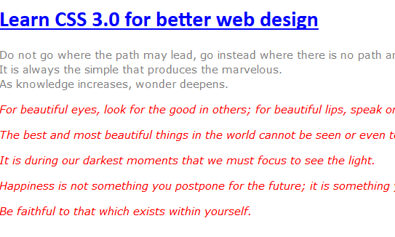

**\*\*\*\*\*\*\*\*\*\*\*\*\*\*\*\*\*\*\*\*\*\*\*\*\*\*\*\*\*022-id.css\*\*\*\*\*\*\*\*\*\*\*\*\*\*\*\*\*\*\*\*\*\*\*\*\*\*\*\*\*\*\*\*\***

@CHARSET "ISO-8859-1";

h1 {

font-family: calibri;

font-size: 30px;

color: blue;

text-decoration: underline;

}

div#d1 {

font-family: verdana;

color: violet;

font-size: 15px;

}

div#d2 {

font-family: verdana;

color: indigo;

font-size: 15px;

}

div#d3 {

font-family: verdana;

color: blue;

font-size: 15px;

}

p#p1 {

font-family: terbuchet-ms;

color: green;

font-size: 15px;

}

p#p2 {

font-family: terbuchet-ms;

color: red;

font-size: 15px;

}

p#p3 {

font-family: terbuchet-ms;

color: orange;

font-size: 15px;

}

p#p4 {

font-family: terbuchet-ms;

color: yellow;

font-size: 15px;

}

p#p5 {

font-family: terbuchet-ms;

color: powderblue;

font-size: 15px;

}

**\*\*\*\*\*\*\*\*\*\*\*\*\*\*\*\*\*\*\*\*\*022-demoid.html\*\*\*\*\*\*\*\*\*\*\*\*\*\*\*\*\*\*\*\*\*\*\*\*\*\*\*\*\***

<!DOCTYPE html>

<html>

<head>

<meta http-equiv="Content-Type" content="text/html; charset=ISO-8859-1">

<title>ID Selector Demo</title>

<link href="022-id.css" rel="stylesheet">

</head>

<body>

<h1>Learn CSS 3.0 for better web design</h1>

<div id="d1">Do not go where the path may lead, go instead where

there is no path and leave a trail.</div>

<div id="d2">It is always the simple that produces the marvelous.

</div>

<div id="d3">As knowledge increases, wonder deepens.</div>

<p id="p1">For beautiful eyes, look for the good in others; for

beautiful lips, speak only words of kindness; and for poise, walk with

the knowledge that you are never alone.</p>

<p id="p2">The best and most beautiful things in the world cannot

be seen or even touched - they must be felt with the heart.</p>

<p id="p3">It is during our darkest moments that we must focus to

see the light.</p>

<p id="p4">Happiness is not something you postpone for the future;

it is something you design for the present.</p>

<p id="p5">Be faithful to that which exists within yourself.</p>

</body>

</html>

**////////////////////////////////////output////////////////////////////////////////**

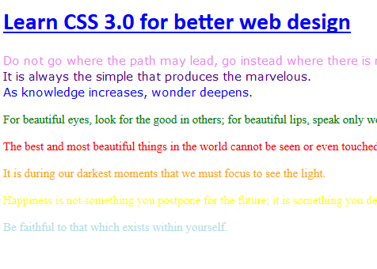

**\*\*\*\*\*\*\*\*\*\*\*\*\*\*\*\*\*\*\*023-type.css\*\*\*\*\*\*\*\*\*\*\*\*\*\*\*\*\*\*\*\*\*\*\*\*\*\*\*\*\***

@CHARSET "ISO-8859-1";

h1

{

font-family:calibri;

font-size:30px;

color:blue;

}

div

{

font-family:verdana;

color:pink;

font-size:15px;

}

p

{

font-family:terbuchet-ms;

color:grey;

font-size:15px;

}

**\*\*\*\*\*\*\*\*\*\*\*\*\*\*\*\*\*\*\*\*023-demoType.html\*\*\*\*\*\*\*\*\*\*\*\*\*\*\*\*\*\*\*\*\*\*\*\*\*\*\*\*\*\*\*\*\*\*\***

<!DOCTYPE html>

<html>

<head>

<meta http-equiv="Content-Type" content="text/html; charset=ISO-8859-1">

<title>Type Selector - Demo</title>

<link href="023-type.css" rel="stylesheet">

</head>

<body>

<h1>Learn CSS 3.0 for better web design</h1>

<div>Do not go where the path may lead, go instead where there is

no path and leave a trail.</div>

<div>It is always the simple that produces the marvelous.</div>

<div>As knowledge increases, wonder deepens.</div>

<p>For beautiful eyes, look for the good in others; for beautiful

lips, speak only words of kindness; and for poise, walk with the

knowledge that you are never alone.</p>

<p>The best and most beautiful things in the world cannot be seen

or even touched - they must be felt with the heart.</p>

<p>It is during our darkest moments that we must focus to see the

light.</p>

<p>Happiness is not something you postpone for the future; it is

something you design for the present.</p>

<p>Be faithful to that which exists within yourself.</p>

</body>

</html>

**///////////////////////////////////////output//////////////////////////////////////////////////**

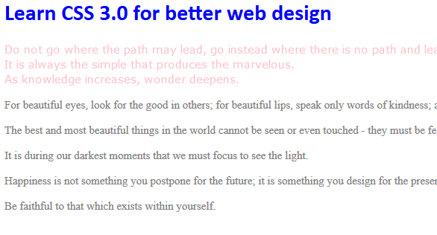

**\*\*\*\*\*\*\*\*\*\*\*\*\*\*\*\*\*\*\*\*\*\*\*\*\*\*\*\*\*\*024-demoPseudoClasses.html\*\*\*\*\*\*\*\*\*\*\*\*\*\*\*\*\*\*\***

<!DOCTYPE html>

<html>

<head>

<style>

a:link {

text-decoration: none;

color: gray;

}

a:visited {

text-decoration: none;

color: red;

}

a:hover {

text-decoration: none;

color: green;

font-weight: bolder;

letter-spacing: 2px;

}

</style>

</head>

<body>

<h2>CSS Pseudo Classes or Links</h2>

<p>

This is a <a href="">link with Pseudo Classes</a> !<br/>

This is a <a href="">link with another Pseudo Classes</a> !

</p>

</body>

</html>

**///////////////////////////////////output/////////////both in red color////////////////////////////**

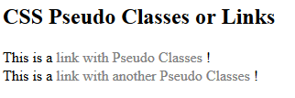

**\*\*\*\*\*\*\*\*\*\*\*\*\*\*\*\*\*\*\*\*\*\*\*\*25-attribute-selector.css\*\*\*\*\*\*\*\*\*\*\*\*\*\*\*\*\*\***

@CHARSET "ISO-8859-1";

img[title]

{

border:5px solid green;

}

img[width]

{

border:10px solid black;

}

img[src="Ball.gif"]

{

border: 20px solid blue;

}

[target] {

font-size: 20px;

background-color: pink;

}

[target=_blank] {

font-size: 20px;

background-color: cyan;

}

[title~=last] {

font-size: 30px;

background-color: grey;

}

div[title|="small"]

{

border:5px solid pink;

}

/* ^(start) $(end) and * */

/*

[title$="div"]

{

background-color:lightgrey;

}

*/

**\*\*\*\*\*\*\*\*\*\*\*\*\*\*\*\*\*\*\*\*\*\*\*\*\*\*025-demoAttributeSelector\*\*\*\*\*\*\*\*\*\*\*\*\*\*\*\*\*\*\*\*\*\***

<!DOCTYPE html>

<html>

<head>

<meta http-equiv="Content-Type" content="text/html; charset=ISO-8859-1">

<!--<link href="allSelector.css" type="text/css" rel="stylesheet">-->

<link href="attributeSelector.css" type="text/css" rel="stylesheet">

<title>Insert title here</title>

</head>

<body>

<h1>Learn CSS 3.0 for better web design</h1>

Anything you want Search&nbsp;&nbsp;

<a href="http://www.google.com" target="_blank">Google</a>

<br />

<br /> Anything information you want Search&nbsp;&nbsp;

<a href="http://www.wikipedia.org" target="_new">Wiki</a>

<br />

<br /> Your company

<a href="http://www.igate.com">IGATE</a>

<br />

<br />

<h1 id="section1">section1</h1><br />

<img src="Ball.gif" width="100" height="100"/><br />

<img title="mainimage" alt="main image"/><br />

<a href="foo.htm">Go To Foo</a><br />

<p class="maintext">mainText Para</p><br />

<form style="padding: 10px">Form</form><br />

<h4 title=" second last">Last vTitle heading</h4><br/>

<div title="small-so">This is first div</div>

</body>

</html>

**///////////////////////////////output/////////////////////////////////**

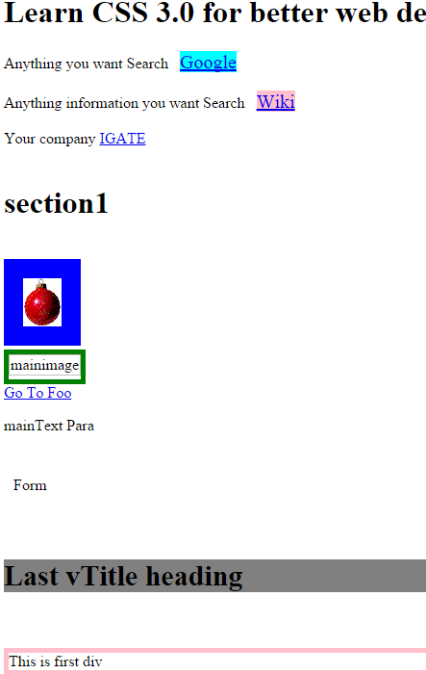

**\*\*\*\*\*\*\*\*\*\*\*\*\*\*\*\*\*\*031-demo4.css\*\*\*\*\*\*\*\*\*\*\*\*\*\*\*\*\*\*\*\*\*\*\*\*\***

@CHARSET "ISO-8859-1";

/* position: static|absolute|fixed|relative|initial|inherit; */

body

{

height:1000px;

width:1000px;

border-style:solid;

border-color:green;

background-color: white;

}

h1

{

margin-left:50px;

width:450px;

background-color: lightgrey;

color: blue;

}

.site-wrapper

{

margin-top:40px;

margin-left:10px;

height:600px;

width:950px;

border-style:solid;

border-color:red;

background-color: #FFFAFA;

}

.top

{

margin-top:60px;

margin-left:10px;

height:30px;

width:950px;

}

.sub-div1

{

margin-top:90px;

margin-left:380px;

left:200px;

width:350px;

height:250px;

border-style:solid;

border-color:blue;

background-color:#B0E0E6;

position: absolute;

}

.sub-div2

{

margin-top:10px;

margin-left:10px;

left:100px;

width:350px;

height:250px;

border-style:solid;

border-color:blue;

background-color: #708090;

position: absolute;

}

**\*\*\*\*\*\*\*\*\*\*\*\*\*\*\*\*\*031-Pos_Absolute.html\*\*\*\*\*\*\*\*\*\*\*\*\*\*\*\*\*\*\*\*\*\*\*\***

<!DOCTYPE html>

<html>

<head>

<meta http-equiv="Content-Type" content="text/html; charset=ISO-8859-1">

<link href="031-demo4.css" rel="stylesheet">

<title>Insert title here</title>

</head>

<body>

<h1>Demonstrating Layout</h1>

<div class="site-wrapper">

<p class="top">An absolute position element is positioned

relative

to the first parent element that has a position

other than static. If

no such element is found,

the containing block is &lt; html &gt;:</p>

<div class="sub-div1">Sub Division - 1</div>

<div class="sub-div2">Sub Division - 2</div>

</div>

</body>

</html>

**/////////////////////////////output///////////////////////////////////////////////////**

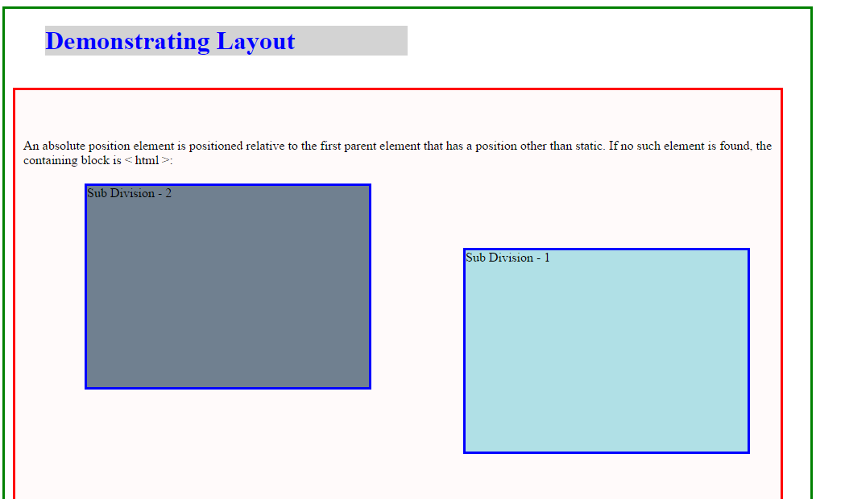

**\*\*\*\*\*\*\*\*\*\*\*\*\*\*\*\*\*\*\*\*\*\*\*\*\*\*031-Pos_Absolute_1.html\*\*\*\*\*\*\*\*\*\*\*\*\*\*\*\*\*\*\***

<!DOCTYPE html>

<html>

<head>

<style>

h1 {

position: absolute;

top: 100px;

left: 50px;

color: red;

}

</style>

</head>

<body>

Position the heading element 50px from the left,

and 100px from the top, relative to the HTML page.

<h1>This is a Heading</h1>

<p>This is a paragraph.</p>

<p>This is another paragraph.</p>

</body>

</html>

**////////////////////////////////////output/////////////////////////////////////////**

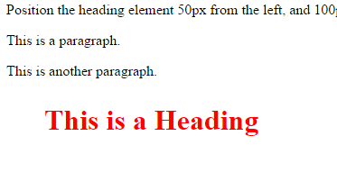

**\*\*\*\*\*\*\*\*\*\*\*\*\*\*\*\*\*\*031-Pos_Absolute_2.html\*\*\*\*\*\*\*\*\*\*\*\*\*\*\*\*\*\*\*\*\*\***

<!DOCTYPE html>

<html>

<head>

<style>

img {

position: absolute;

left: 0px;

top: 0px;

z-index: -1;

}

</style>

</head>

<body>

<h1>This is a Heading</h1>

<p>This is a paragraph.</p>

<p>This is another paragraph.</p>

<img src="Ball.gif" width="100" height="140">

</body>

</html>

**//////////////////////////////////output/////////////////////////////////////////////////**

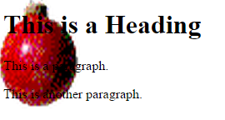

**\*\*\*\*\*\*\*\*\*\*\*\*\*\*\*\*\*031-absolutedemo.html\*\*\*\*\*\*\*\*\*\*\*\*\*\*\*\*\*\***

<style>

div.relative {

position: relative;

width: 400px;

height: 200px;

border: 3px solid #8AC007;

}

div.absolute {

position: absolute;

top: 40px;

right: 0;

width: 200px;

height: 100px;

border: 3px solid #8AC007;

}

</style>

</head>

<body>

<h2>position: absolute;</h2>

<p>An element with position: absolute; is positioned relative to the nearest positioned ancestor (instead of positioned relative to the viewport, like fixed):</p>

<div class="relative">This <div> element has position: relative;

<div class="absolute">This <div> element has position: absolute;</div>

</div>

</body>

</html>

**///////////////////////////output///////////////////////////////////////////////////////////**

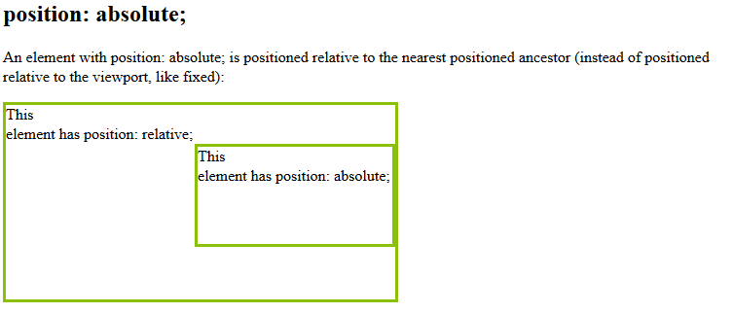

**\*\*\*\*\*\*\*\*\*\*\*\*\*\*\*\*\*\*\*\*\*\*\*\*\*\*\*\*\*\*\*\*\*\*032-demo.css\*\*\*\*\*\*\*\*\*\*\*\*\*\*\*\*\*\*\*\***

@CHARSET "ISO-8859-1";

h1

{

margin-left:10px;

width:950px;

background-color: lightgrey;

color: #E9967A;

}

.site-wrapper

{

margin-top:10px;

margin-left:10px;

height:550px;

width:950px;

border-style:solid;

border-color:red;

background-color: #FFFAFA;

}

.sub-div1

{

top:100px;

left:100px;

margin-top:10px;

margin-left:10px;

width:900px;

height:250px;

border-style:solid;

border-color:blue;

background-color:#B0E0E6;

position: fixed;

}

**\*\*\*\*\*\*\*\*\*\*\*\*\*\*\*\*\*\*\*032-Pos_Fixed.html\*\*\*\*\*\*\*\*\*\*\*\*\*\*\*\*\*\*\*\*\*\*\*\*\*\*\*\*\*\*\*\*\***

<!DOCTYPE html>

<html>

<head>

<meta http-equiv="Content-Type" content="text/html; charset=ISO-8859-1">

<title>Insert title here</title>

<link href="032-demo2.css" rel="stylesheet">

</head>

<body>

<h1>Demonstrating Layout</h1>

<div class="site-wrapper">

<div class="sub-div1">

<h2>Fixed Positioning</h2>

An element with fixed position is positioned relative to the browser window.

It will not move even if the window is scrolled:

</div>

</div>

</body>

</html>

**////////////////////////////////output/////////////////////////////////////////////**

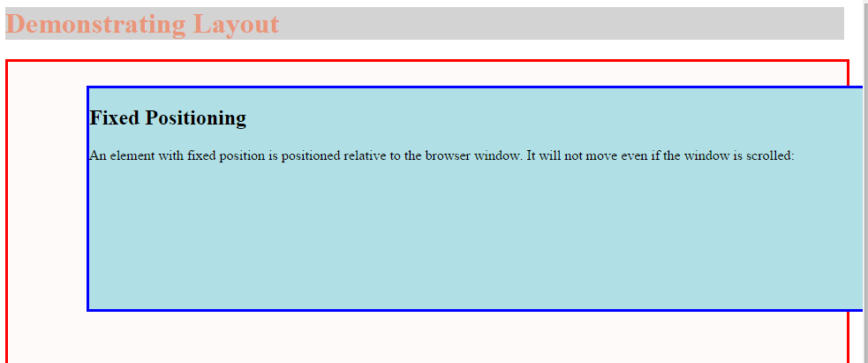

**\*\*\*\*\*\*\*\*\*\*\*\*\*\*\*\*032-Pos_Fixed_1.html\*\*\*\*\*\*\*\*\*\*\*\*\*\*\*\*\*\*\*\*\*\*\*\*\*\*\*\*\*\*\*\*\*\*\*\*\*\*\*\*\*\***

<!DOCTYPE html>

<html>

<head>

<style>

h1 {

position: fixed;

top: 50px;

right: 50px;

color: red;

}

</style>

</head>

<body>

Position the heading element relative to the browser window. 50px from the top, and 50px from the right.

<h1>This is a Heading.</h1>

<p>This is a paragraph.</p>

<p>This is another paragraph.</p>

</body>

</html>

**///////////////////////////////output/////////////////////////////////////////////**

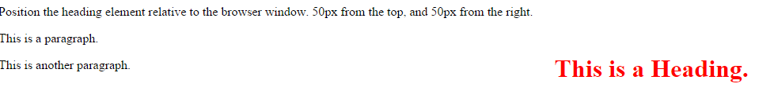

**\*\*\*\*\*\*\*\*\*\*\*\*\*\*\*\*\*033-Pos_Relative_00.html\*\*\*\*\*\*\*\*\*\*\*\*\*\*\*\*\*\*\*\*\*\*\*\***

<!DOCTYPE html>

<html>

<head>

<style>

div.relative {

position: relative;

left: 30px;

border: 3px solid #8AC007;

}

h4 {

position: relative;

left: 300px;

}

</style>

</head>

<body>

<h2>position: relative;</h2>

<p>An element with position: relative; is positioned relative to its normal position:</p>

<div class="relative">

This div element has position: relative;

</div>

<h4>position: relative;</h>

</body>

</html>

**/////////////////////////////////////////output////////////////////////////////////////////**

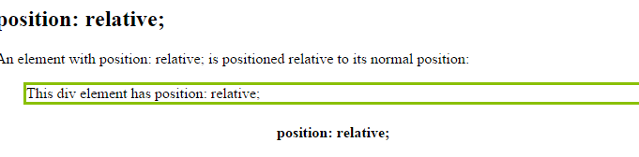

**\*\*\*\*\*\*\*\*\*\*\*\*\*\*\*\*\*\*\*\*\*\*\*\*\*\*\*033-Pos_Relative_01.html\*\*\*\*\*\*\*\*\*\*\*\*\*\*\*\*\***

<!DOCTYPE html>

<html>

<head>

<style>

h1 {

position: relative;

top: 30px;

left: -20px;

color: red;

}

</style>

</head>

<body>

Position the heading element 20px left, and 30px down,

relative to its normal position.

<h1>This is a Heading</h1>

<p>This is a paragraph.</p>

<p>This is another paragraph.</p>

</body>

</html>

**////////////////////////////////////////output/////////////////////////////////////////**

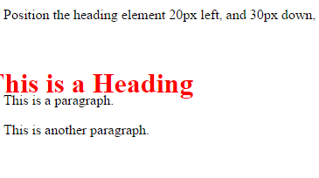

**\*\*\*\*\*\*\*\*\*\*\*\*\*\*\*\*\*\*\*\*033-demo.css\*\*\*\*\*\*\*\*\*\*\*\*\*\*\*\*\*\*\*\*\*\*\*\*\*\*\***

@CHARSET "ISO-8859-1";

h1

{

margin-left:10px;

width:950px;

background-color: lightgrey;

color: #E9967A;

}

.site-wrapper

{

margin-top:10px;

margin-left:10px;

height:550px;

width:950px;

border-style:solid;

border-color:red;

background-color: #FFFAFA;

}

.sub-div1

{

margin-top:30px;

margin-left:70px;

width:800px;

height:150px;

border-style:solid;

border-color:blue;

background-color:#B0E0E6;

position:relative;

}

.sub-div2

{

margin-top:10px;

margin-left:70px;

left:-30px;

width:800px;

height:200px;

border-style:solid;

border-color:blue;

background-color:#B0E0E6;

position:relative;

}

.sub-div3

{

margin-top:10px;

margin-left:10px;

right:-30px;

width:800px;

height:80px;

border-style:solid;

border-color:blue;

background-color:#B0E0E6;

position:relative;

}

**\*\*\*\*\*\*\*\*\*\*\*\*\*\*\*\*\*\*\*\*\*\*\*\*\*\*\*033-Pos_Relative_02.html\*\*\*\*\*\*\*\*\*\*\*\*\*\*\*\*\***

<!DOCTYPE html>

<html>

<head>

<meta http-equiv="Content-Type" content="text/html; charset=ISO-8859-1">

<title>Insert title here</title>

<link href="033-demo3.css" rel="stylesheet">

</head>

<body>

<h1>Demonstrating Layout</h1>

<div class="site-wrapper">

<div class="sub-div1">

<h2>Relative Positioning</h2>

A relative positioned element is positioned relative to its normal position.

The content of relatively positioned elements can be moved and overlap other elements,

but the reserved space for the element is still preserved in the normal flow

<br/>

Division with no POSITION!!

</div>

<div class="sub-div2">

This division is moved left according to it's normal POSITION

</div>

<div class="sub-div3">

This division is moved right according to it's normal POSITION

</div>

</div>

</body>

</html>

////////////////////////////////////////.output//////////////////////////////

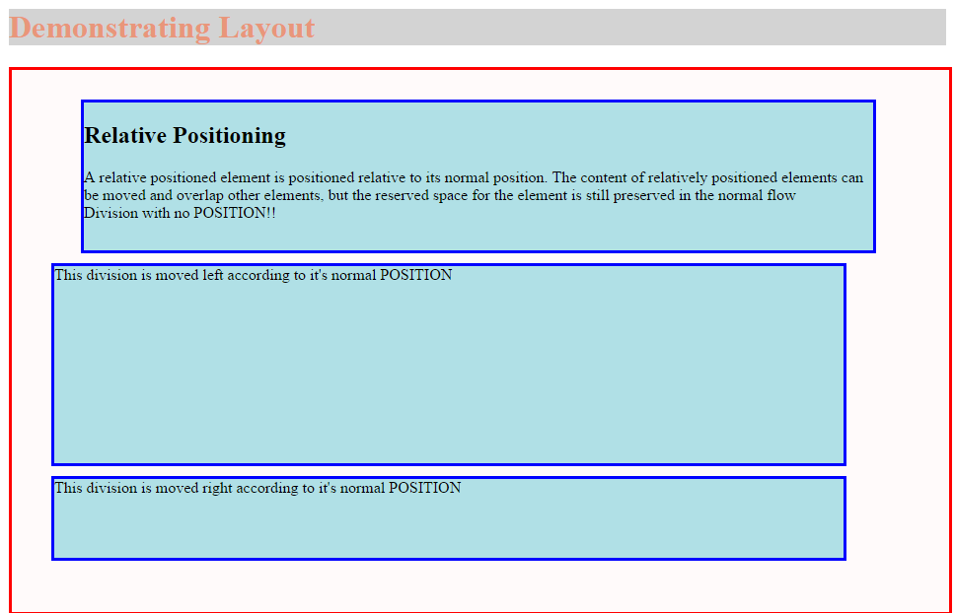

**\*\*\*\*\*\*\*\*\*\*\*\*\*\*\*\*\*\*\*034-Pos_Static_00.html\*\*\*\*\*\*\*\*\*\*\*\*\*\*\*\*\*\*\*\*\*\***

<!DOCTYPE html>

<html>

<head>

<style>

div.static {

position: static;

border: 3px solid #8AC007;

}

</style>

</head>

<body>

<h2>position: static;</h2>

<p>An element with position: static; is not positioned in any special way; it is

always positioned according to the normal flow of the page:</p>

<div class="static">

This div element has position: static;

</div>

</body>

</html>

**///////////////////////////////output//////////////////////////////////////////////////////**

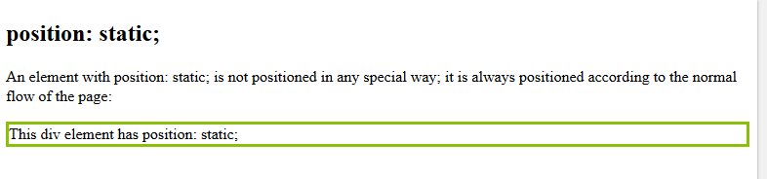

**\*\*\*\*\*\*\*\*\*\*\*\*\*\*\*\*\*034-Pos_Static_01.html\*\*\*\*\*\*\*\*\*\*\*\*\*\*\*\*\*\*\*\*\*\*\*\*\*\*\*\*\*\*\*\*\*\*\*\*\*\*\*\*\*\*\*\*\*\*\*\*\*\*\*\*\*\***

<!DOCTYPE html>

<html>

<head>

<meta http-equiv="Content-Type" content="text/html; charset=ISO-8859-1">

<title>Insert title here</title>

<link href="034-demo1.css" rel="stylesheet">

</head>

<body>

<h1>Demonstrating Layout</h1>

<div class="site-wrapper">

<div class="sub-div1">

<h2>Static Positioning</h2>

HTML elements are positioned static by default. A static positioned element is always positioned according to the normal flow of the page.

Static positioned elements are not affected by the top, bottom, left, and right properties.

</div>

<div class="sub-div1">

<h2>Static Positioning</h2>

HTML elements are positioned static by default. A static positioned element is always positioned according to the normal flow of the page.

Static positioned elements are not affected by the top, bottom, left, and right properties.

</div>

</div>

</body>

</html>

**//////////////////////////////////034-demo1.css///////////////////////////////////////**

@CHARSET "ISO-8859-1";

h1

{

margin-left:10px;

width:950px;

background-color: lightgrey;

color: #E9967A;

}

.site-wrapper

{

margin-top:10px;

margin-left:10px;

height:550px;

width:950px;

border-style:solid;

border-color:red;

background-color: #FFFAFA;

}

.sub-div1

{

//top:100px;

//left:100px;

margin-top:10px;

margin-left:10px;

width:900px;

height:250px;

border-style:solid;

border-color:blue;

background-color:#B0E0E6;

position: static;

}

**//////////////////////////////////output/////////////////////////////////////////**

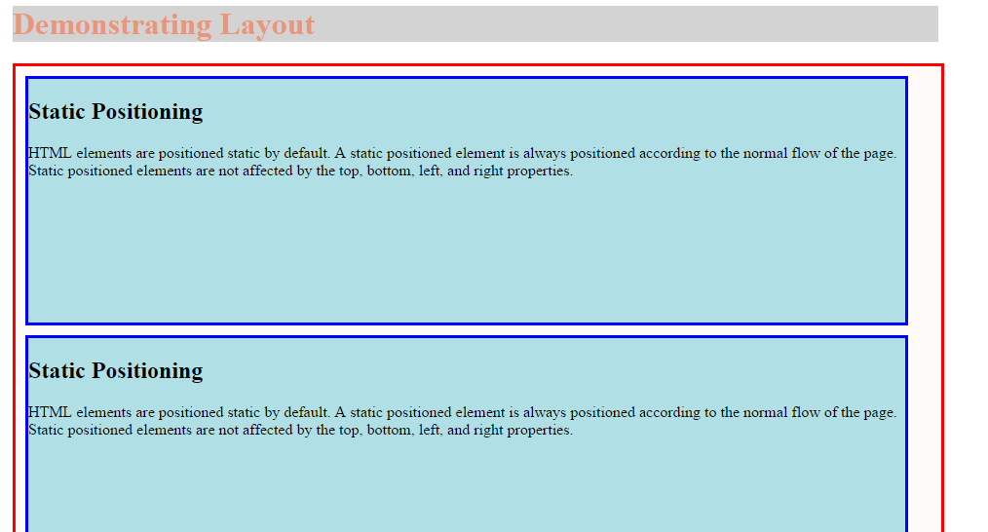

**\*\*\*\*\*\*\*\*\*\*\*\*\*\*\*\*\*\*\*035-Float-demo5_0.html\*\*\*\*\*\*\*\*\*\*\*\*\*\*\*\*\*\*\*\*\*\*\***

<!DOCTYPE html>

<html>

<head>

<style>

img {

float: right;

margin: 0 0 10px 10px;

}

</style>

</head>

<body>

<p>In this example,

the image will float to the right in the paragraph,

and the text in the paragraph will wrap around the image.</p>

<p>

<img src="Ball.gif" alt="Ball.com" width="100" height="140">

Lorem ipsum dolor sit amet, consectetur adipiscing elit.

Phasellus imperdiet, nulla et dictum interdum,

nisi lorem egestas odio, vitae scelerisque enim

ligula venenatis dolor. Maecenas nisl est, ultrices nec congue

eget, auctor vitae massa. Fusce luctus vestibulum augue ut aliquet.

Mauris ante ligula, facilisis sed ornare eu, lobortis in odio.

Praesent convallis urna a lacus interdum ut hendrerit risus congue.

Nunc sagittis dictum nisi, sed ullamcorper ipsum dignissim ac.

In at libero sed nunc venenatis imperdiet sed ornare turpis.

Donec vitae dui eget tellus gravida venenatis. Integer fringilla

congue eros non fermentum. Sed dapibus pulvinar nibh tempor porta.

Cras ac leo purus. Mauris quis diam velit.</p>

</body>

</html>

**//////////////////////////////////output/////////////////////////////////////////**

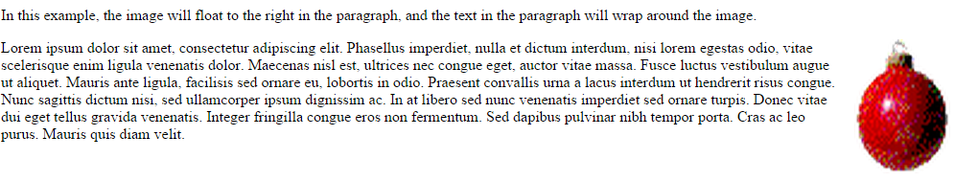

**\*\*\*\*\*\*\*\*\*\*\*\*\*\*\*\*\*\*\*\*\*035-Float-demo5.css\*\*\*\*\*\*\*\*\*\*\*\*\*\*\*\*\*\*\*\*\*\*\*\*\***

@CHARSET "ISO-8859-1";

h1

{

margin-left:10px;

width:950px;

background-color: lightgrey;

color: #E9967A;

}

.site-wrapper

{

margin-top:10px;

margin-left:10px;

height:1100px;

width:950px;

border-style:solid;

border-color:red;

background-color: #FFFAFA;

}

.sub-div1

{

margin-top:10px;

margin-left:10px;

width:250px;

height:250px;

border-style:solid;

border-color:blue;

background-color:#FF7F50;

position:relative;

float:right;

//float:left;

}

.sub-div2

{

margin-top:10px;

margin-left:10px;

width:250px;

height:250px;

border-style:solid;

border-color:blue;

background-color:#00FFFF;

//float:right;

float:left;

}

.sub-div3

{

margin-top:10px;

margin-left:10px;

width:250px;

height:250px;

border-style:solid;

border-color:blue;

background-color:#B0E0E6;

//float:right;

float:left;

}

.sub-div4

{

margin-top:10px;

margin-left:10px;

width:100px;

height:250px;

border-style:solid;

border-color:blue;

background-color:#8A2BE2;

float:right;

//float:left;

}

**\*\*\*\*\*\*\*\*\*\*\*\*\*\*\*\*\*\*\*\*\*\*\*.035-Float-demo5_1.html\*\*\*\*\*\*\*\*\*\*\*\*\*\*\*\*\*\*\*\*\*\*\*\*\*\*\*\*\*\*\*\*\*\***

<!DOCTYPE html PUBLIC "-//W3C//DTD HTML 4.01 Transitional//EN" "http://www.w3.org/TR/html4/loose.dtd">

<html>

<head>

<meta http-equiv="Content-Type" content="text/html; charset=ISO-8859-1">

<link href="035-Float-demo5.css" type="text/css" rel="stylesheet">

<title>Insert title here</title>

</head>

<body>

<h1>Demonstrating Layout</h1>

<div class="site-wrapper">

<div class="sub-div1">

Sub Division - 1

</div>

<div class="sub-div2">

Sub Division - 2

</div>

<div class="sub-div3">

Sub Division - 3

</div>

<div class="sub-div4">

Sub Division - 4

</div>

</div>

</body>

</html>

**//////////////////////////////////output/////////////////////////////////////////**

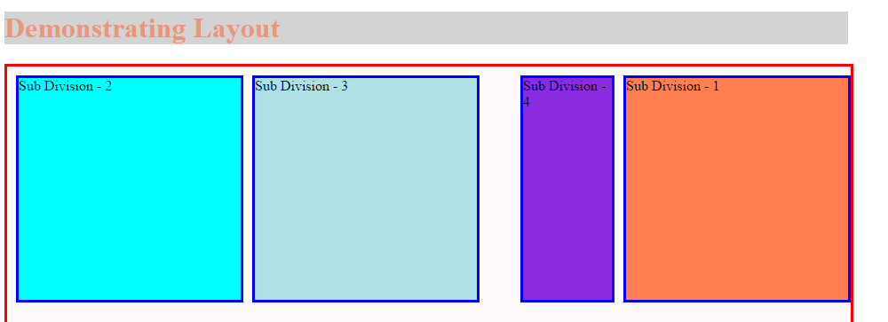

**\*\*\*\*\*\*\*\*\*\*\*\*\*\*\*\*\*\*\*\*035-float-clear-demo.html\*\*\*\*\*\*\*\*\*\*\*\*\*\*\*\*\*\*\*\*\*\*\*\*\*\*\***

<!DOCTYPE html>

<html>

<head>

<style>

.div1 {

float: left;

width: 100px;

height: 50px;

margin: 10px;

border: 3px solid #8AC007;

}

.div2 {

border: 1px solid red;

}

.div3 {

float: left;

width: 100px;

height: 50px;

margin: 10px;

border: 3px solid #8AC007;

}

.div4 {

border: 1px solid red;

clear: left;

}

</style>

</head>

<body>

<h2>Without clear</h2>

<div class="div1">div1</div>

<div class="div2">div2 - Notice that the div2 element is after div1, in the HTML code. However, since div1 is floated to the left, this happens: the text in div2 is floated around div1, and div2 surrounds the whole thing.</div>

<h2>Using clear</h2>

<div class="div3">div3</div>

<div class="div4">div4 - Using clear moves div4 down below the floated div3. The value "left" clears elements floated to the left. You can also clear "right" and "both".</div>

</body>

</html>

**//////////////////////////////////output/////////////////////////////////////////**

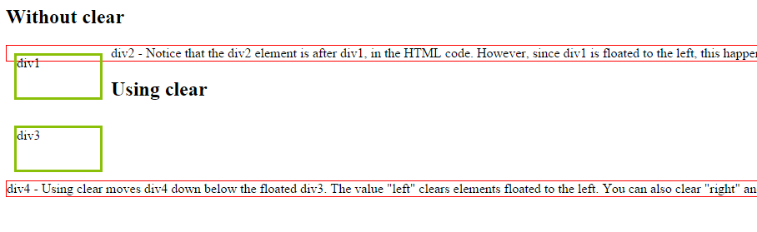

**\*\*\*\*\*\*\*\*\*\*\*\*\*\*\*\*\*36******036-BoxLayout\*\*\*\*\*\*\*\*\*\*\*\*\*\*\*\*\*\*\*\*\*\*\*\***

**\*\*\*\*\*\*\*\*\*\*\*\*\*\*Borders and Transformation\*\*\*\*\*\*\*\*\*\*\*\*\*\*\*\*\*\*\*\*\*\*\***

Edit This Code:

See Result »

<!DOCTYPE html>

<html>

<head>

<style>

div {

background-color: pink;

width: 400px;

padding: 55px;

border: 25px solid navy;

margin: 50px;

}

</style>

</head>

<body>

<div>Lorem ipsum dolor sit amet, consectetur adipiscing elit,

sed do eiusmod tempor incididunt ut labore et

dolore magna aliqua. Ut enim ad minim veniam,

quis nostrud exercitation ullamco laboris nisi ut aliquip ex ea commodo consequat. Duis aute irure dolor in reprehenderit in voluptate velit esse cillum dolore eu fugiat nulla pariatur. Excepteur sint occaecat cupidatat non proident, sunt in culpa qui officia deserunt mollit anim id est laborum.</div>

</body>

</html>

Result:

**/////////////////////////////output/////////////////////////////////////////////////////////////////**

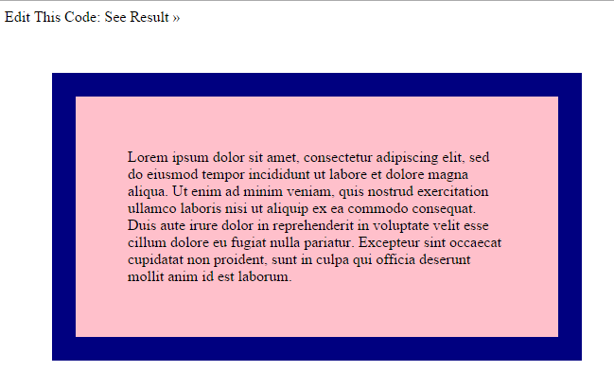

**\*\*\*\*\*\*\*\*\*\*\*\*\*\*\*\*\*\*\*\*\*\*\*\*\*\*\*\*\*\*\*\*\*\*\*037-demo7.css\*\*\*\*\*\*\*\*\*\*\*\*\*\*\*\*\*\*\*\*\*\*\*\*\*\*\*\*\*\*\***

@CHARSET "ISO-8859-1";

h1

{

background-color: lightgrey;

color: #E9967A;

}

.tb1

{

table-layout:auto

}

.tb2

{

table-layout:fixed

}

**\*\*\*\*\*\*\*\*\*\*\*\*\*\*\*\*\*\*\*\*\*\*\*\*\*\*\*\*037-table_layout.html\*\*\*\*\*\*\*\*\*\*\*\*\*\*\*\*\*\*\*\*\*\*\*\*\*\*\*\*\*\*\***

<!DOCTYPE html>

<html>

<head>

<meta http-equiv="Content-Type" content="text/html; charset=ISO-8859-1">

<title>Insert title here</title>

<link href="037-demo7.css" rel="stylesheet">

</head>

<body>

<h1>Demonstrating Table Layout</h1>

<table class="tb1" border="1" width="100%">

<tr>

<td width="5%">1000000000000000000000000000</td>

<td width="95%">10000000</td>

</tr>

</table>

<br>

<table class="tb2" border="1" width="100%">

<tr>

<td width="5%">1000000000000000000000000000</td>

<td width="95%">10000000</td>

</tr>

</table>

</body>

</html>

**/////////////////////////output/////////////////////////////////////////////////////**

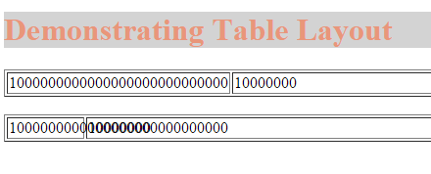

**\*\*\*\*\*\*\*\*\*\*\*\*\*\*\*\*\*\*\*\*\*\*\*\*\*\*038-flex_box .css\*\*\*\*\*\*\*\*\*\*\*\*\*\*\*\*\*\*\*\*\***

@CHARSET "ISO-8859-1";

div

{

display:-webkit-box;

width:600px;

border:1px solid black;

}

#p1

{

-webkit-box-flex:1.0;

border:4px solid red;

}

#p2

{

-webkit-box-flex:3.0;

border:1px solid blue;

}

**\*\*\*\*\*\*\*\*\*\*\*\*\*\*\*\*\*\*\*\*\*\*\*\*\*\*\*038-fexi_box_layout.html \*\*\*\*\*\*\*\*\*\*\*\*\*\*\*\*\*\*\*\*\*\*\*\*\*\***

<!DOCTYPE html>

<html>

<head>

<link href="038-flex_box.css" rel="stylesheet" />

</head>

<body>

<h1>Flexi Box Layout Demo</h1>

<div> Div Section

<p id="p1">IGATE Corporate University</p>

<p id="p2">IGATE Corporate University is known for its training

methodologies</p>

</div>

</body>

</html>

**////////////////////////////////////Output///////////////////////////////////////////**

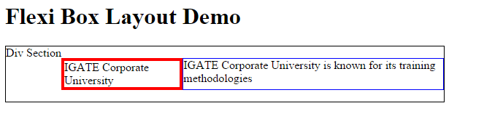

**\*\*\*\*\*\*\*\*\*\*\*\*\*\*\*\*\*\*\*\*\*\*\*\*\*\*\*\*\*038-table_layout .html\*\*\*\*\*\*\*\*\*\*\*\*\*\*\*\*\*\*\*\*\*\*\*\*\*\*\*\*\***

<!DOCTYPE html>

<html>

<head>

<style>

table {

border-collapse: separate;

width: 100%;

border: 1px solid black;

}

td {

border: 1px solid black;

}

table.ex1 {

table-layout: auto;

}

table.ex2 {

table-layout: fixed;

}

</style>

</head>

<body>

<p>table-layout: auto:</p>

<table class="ex1">

<tr>

<td width="5%">1000000000000000000000000000</td>

<td width="95%">10000000</td>

</tr>

</table>

<p>table-layout: fixed:</p>

<table class="ex2">

<tr>

<td width="5%">1000000000000000000000000000</td>

<td width="95%">10000000</td>

</tr>

</table>

</body>

</html>

**/////////////////////////////////////output///////////////////////////////////**

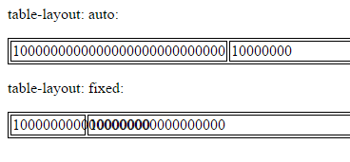

**\*\*\*\*\*\*\*\*\*\*\*\*\*\*\*\*\*\*\*\*\*\*\*\*\*\*\*\*\*\*\*\*\*\*\*039-demo8.css\*\*\*\*\*\*\*\*\*\*\*\*\*\*\*\*\*\*\*\*\*\*\*\*\***

@CHARSET "ISO-8859-1";

h1

{

background-color: lightgrey;

color: #E9967A;

}

.wol

{

-webkit-column-count:3;

-webkit-column-gap: 1em;

-webkit-column-rule: 1px solid black;

}

**\*\*\*\*\*\*\*\*\*\*\*\*\*\*\*\*\*\*\*\*\*\*\*\*039-multi_column.html\*\*\*\*\*\*\*\*\*\*\*\*\*\*\*\*\*\*\*\*\*\*\*\*\*\*\***

<!DOCTYPE html>

<html>

<head>

<meta http-equiv="Content-Type" content="text/html; charset=ISO-8859-1">

<title>Insert title here</title>

<link href="039-demo8.css" rel="stylesheet">

</head>

<body>

<h1>Wisdom of Life</h1>

<p class="wol">We have already seen, in general, that what a man is

contributes much more to his happiness than what he has, or how he is

regarded by others. What a man is, and so what he has in his own

person, is always the chief thing to consider; for his individuality

accompanies him always and everywhere, and gives its color to all his

experiences. In every kind of enjoyment, for instance, the pleasure

depends principally upon the man himself. Every one admits this in

regard to physical, and how much truer it is of intellectual,

pleasure. When we use that English expression, "to enjoy one's self,"

we are employing a very striking and appropriate phrase; for observe -

one says, not "he enjoys Paris," but "he enjoys himself in Paris." To

a man possessed of an ill-conditioned individuality, all pleasure is

like delicate wine in a mouth made bitter with gall. Therefore, in the

blessings as well as in the ills of life, less depends upon what

befalls us than upon the way in which it is met, that is, upon the

kind and degree of our general susceptibility. What a man is and has

in himself,- in a word personality, with all it entails, is the only

immediate and direct factor in his happiness and welfare. All else is

mediate and indirect, and its influence can be neutralized and

frustrated; but the influence of personality never. This is why the

envy which personal qualities excite is the most implacable of all,-

as it is also the most carefully dissembled.</p>

</body>

</html>

**/////////////////////////////Output//////////////////////////////////////////**

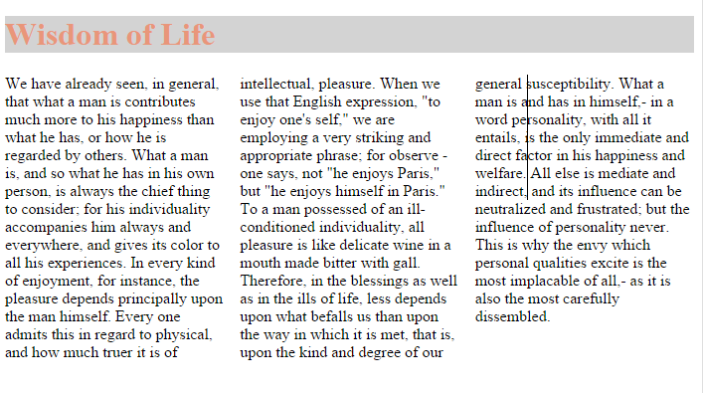

**\*\*\*\*\*\*\*\*\*\*\*\*\*\*\*\*\*Not Printed\*\*\*\*\*\*\*\*\*\*\*\*\*\*\*\*\*\*\*\*\*\*\*\*\*\*\*\*\*\***

**\*\*\*\*\*\*\*\*\*\*\*\*\*\*\*\*\*\*\*\*\*\*\*\*\*FlexLayOutDemoProperties\*\*\*\*\*\*\*\*\*\*\*\*\*\*\*\*\*\*\*\*\*\*\*\*\*\*\***

**\*\*\*\*\*\*\*\*\*\*\*\*\*\*\*\*\*flex_box.css\*\*\*\*\*\*\*\*\*\*\*\*\*\*\*\*\*\*\*\*\*\*\*\*\*\*\*\*\*\*\*\*\*\*\***

@CHARSET "ISO-8859-1";

div

{

display:-webkit-box;

width:1600px;

border:1px solid black;

-webkit-box-orients:horizontal;

/*-webkit-box-direction: reverse;*/

}

#p1

{

-webkit-box-flex:1;

border:1px solid red;

-webkit-box-ordinal-group: 2;

}

#p2

{

-webkit-box-flex:1;

border:1px solid blue;

-webkit-box-ordinal-group: 3;

}

#p3

{

-webkit-box-flex:1;

border:1px solid green;

-webkit-box-ordinal-group: 1;

}

**\*\*\*\*\*\*\*\*\*\*\*\*\*\*\*\*\*\*\*\*\*flex_box_layout.html\*\*\*\*\*\*\*\*\*\*\*\*\*\*\*\*\*\*\*\*\*\*\*\*\*\*\*\*\*\***

<!DOCTYPE html>

<html>

<head>

<link href="flex_box.css" rel="stylesheet" />

</head>

<body>

<h1>Flexi Box Layout Demo</h1>

<div>

<p id="p1">IGATE Corporate University is known for its training

methodologies 1</p>

<p id="p2">IGATE Corporate University is known for its training

methodologies 2</p>

<p id="p3">IGATE Corporate University is known for its training

methodologies3 </p>

</div>

</body>

</html>

**\*\*\*\*\*\*\*\*\*\*\*\*\*\*\*output\*\*\*\*\*\*\*\*\*\*\*\*\*\*\*\*\*\*\*\*\*\*\*\*\*\*\*\*\*\*\*\*\*\*\*\*\*\*\*\*\*\*\*\***



**\*\*\*\*\*\*\*\*\*\*\*\*\*\*\*\*\*\*\*\*FlexLayoutNewApproach.html\*\*\*\*\*\*\*\*\*\*\*\*\*\*\*\*\*\*\*\*\*\*\*\*\*\*\*\*\*\*\*\*\*\*\***

<!DOCTYPE html>

<html>

<head>

<style>

.flex-container

{

width: 100%;

//display: -moz-box;

display: -webkit-box;

//display: box;

//-moz-box-orient: horizontal;

-webkit-box-orient: horizontal;

//box-orient: horizontal;

outline: 1px solid #f00;

margin-bottom: 20px;

}

.flex-container div

{

padding: 10px;

}

.col-1

{

color: #fff;

background: #f00;

}

.col-2

{

color: #fff;

background: #00f;

height: 200px;

}

.col-3

{

background: #0f0;

}

.col-1-flex

{

-moz-box-flex: 1;

-webkit-box-flex: 1;

box-flex: 1;

}

.col-2-flex

{

-moz-box-flex: 1;

-webkit-box-flex: 1;

box-flex: 1;

}

.col-3-flex

{

-moz-box-flex: 2;

-webkit-box-flex: 2;

box-flex: 2;

}

.flex-container-vertical

{

display: -moz-box;

display: -webkit-box;

display: box;

-moz-box-orient: vertical;

-webkit-box-orient: vertical;

box-orient: vertical;

outline: 4px solid #f00;

margin-bottom: 20px;

}

.row-1

{

color: #fff;

background: #f00;

}

.row-2

{

color: #fff;

background: #00f;

height: 200px;

}

.row-3

{

background: #0f0;

}

.flex-container-reverse

{

width: 100%;

display: -moz-box;

display: -webkit-box;

display: box;

-moz-box-orient: horizontal;

-webkit-box-orient: horizontal;

box-orient: horizontal;

-moz-box-direction: reverse;

-webkit-box-direction: reverse;

box-direction: reverse;

outline: 1px solid #f00;

margin-bottom: 20px;

}

.col-1-ordinal

{

-moz-box-ordinal-group: 2;

-webkit-box-ordinal-group: 2;

box-ordinal-group: 2;

}

.col-2-ordinal

{

-moz-box-ordinal-group: 3;

-webkit-box-ordinal-group: 3;

box-ordinal-group: 3;

}

.col-3-ordinal

{

-moz-box-ordinal-group: 1;

-webkit-box-ordinal-group: 1;

box-ordinal-group: 1;

}

.flex-container-center

{

width: 100%;

display: -moz-box;

display: -webkit-box;

-moz-box-orient: horizontal;

-webkit-box-orient: horizontal;

box-orient: horizontal;

-moz-box-pack: center;

-webkit-box-pack: center;

box-pack: center;

outline: 1px solid #f00;

margin-bottom: 20px;

}

.flex-container-justify

{

width: 100%;

display: -moz-box;

display: -webkit-box;

display: box;

-moz-box-orient: horizontal;

-webkit-box-orient: horizontal;

box-orient: horizontal;

-moz-box-pack: justify;

-webkit-box-pack: justify;

box-pack: justify;

outline: 1px solid #f00;

margin-bottom: 20px;

}

</style>

</head>

<body>

<h2>display: box; box-orient: horizontal;</h2>

<div class="flex-container">

<div class="col-1">I am column 1</div>

<div class="col-2">I am column 2</div>

<div class="col-3">I am column 3</div>

</div>

<h2>box-flex</h2>

<div class="flex-container">

<div class="col-1 col-1-flex">I am column 1</div>

<div class="col-2 col-2-flex">I am column 2</div>

<div class="col-3 col-3-flex">I am column 3</div>

</div>

<h2>display: box; box-orient: vertical;</h2>

<div class="flex-container-vertical">

<div class="row-1">I am row 1</div>

<div class="row-2">I am row 2</div>

<div class="row-3">I am row 3</div>

</div>

<h2>box-direction: reverse;</h2>

<div class="flex-container-reverse">

<div class="col-1">I am column 1</div>

<div class="col-2">I am column 2</div>

<div class="col-3">I am column 3</div>

</div>

<h2>box-ordinal-group</h2>

<div class="flex-container">

<div class="col-1 col-1-ordinal">I am column 1</div>

<div class="col-2 col-2-ordinal">I am column 2</div>

<div class="col-3 col-3-ordinal">I am column 3</div>

</div>

<h2>box-pack: center;</h2>

<div class="flex-container-center">

<div class="col-1">I am column 1</div>

<div class="col-2">I am column 2</div>

<div class="col-3">I am column 3</div>

</div>

<h2>box-direction: justify;</h2>

<div class="flex-container-justify">

<div class="col-1">I am column 1</div>

<div class="col-2">I am column 2</div>

<div class="col-3">I am column 3</div>

</div>

</body>

</html>

**\*\*\*\*\*\*\*\*\*\*\*\*\*\*\*\*\*\*\*\*\*\*\*\*output\*\*\*\*\*\*\*\*\*\*\*\*\*\*\*\*\*\*\*\*\*\*\*\*\*\*\*\*\*\*\*\*\*\*\*\*\*\*\*\*\*\*\*\*\*\*\*\***

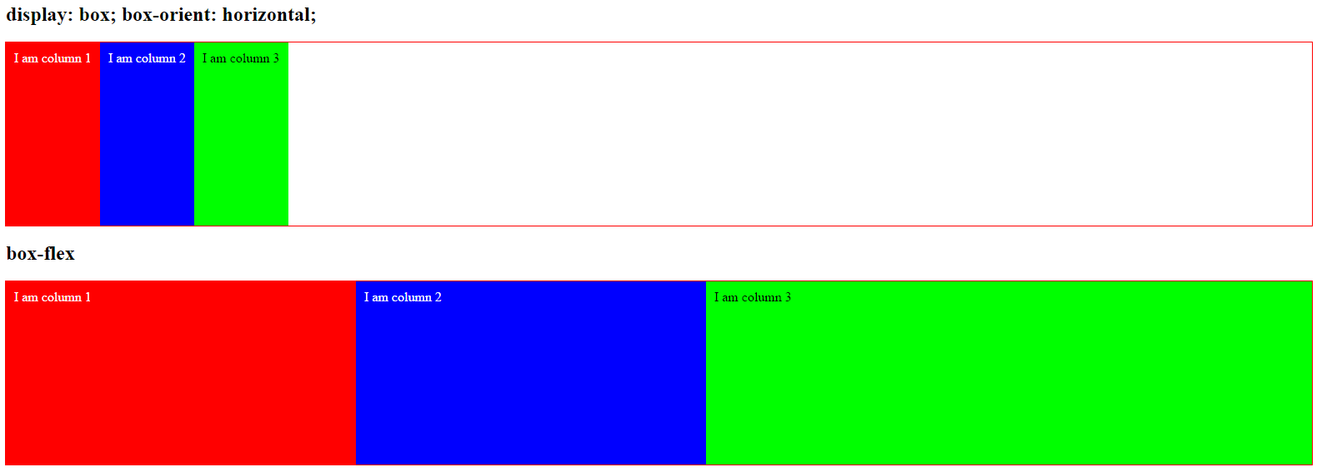

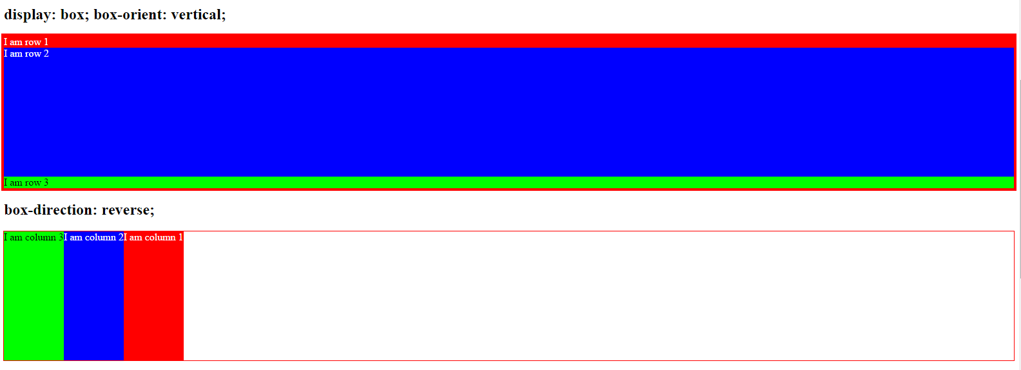

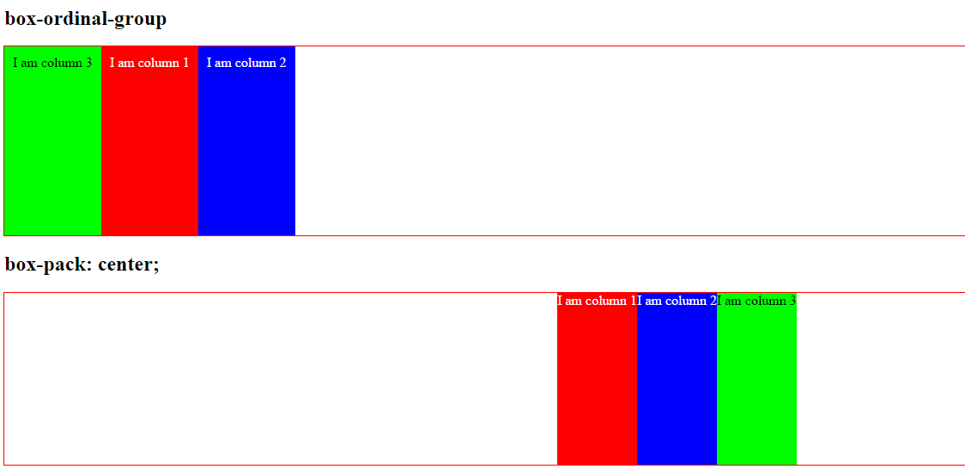

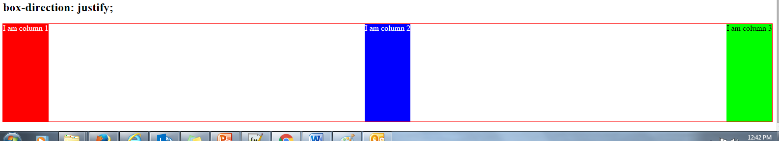

**********************Thank You*****************************************************************